Adult & Youth Bean Bag Tournaments
Chamber Tent
Main St. Janesville
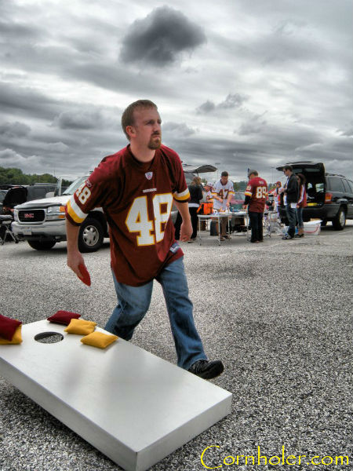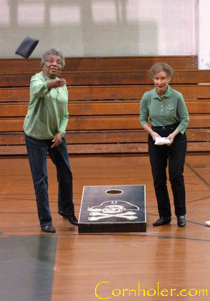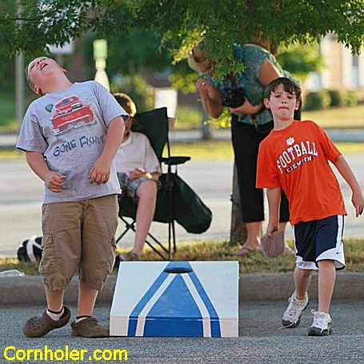

Adult Bean Bag Doubles Tournament
June 17th - 11am-5pm
$20/team (any age)
Reservations: https://www.signupgenius.com/go/10C0C44A8A92FA3FEC25-adult

Youth Bean Bag Doubles Tournament
June 17th - 2pm-5pm
$10/team (ages 18 and under)
Reservations: https://www.signupgenius.com/go/10C0C44A8A92FA3FEC25-youth

Payout depends on the number of teams.
Proceeds to Janesville Area Chamber of Commerce for Hay Daze

Janesville Hay Daze Celebration
June 12th-18th
www.JanesvilleMNHayDaze.weebly.com

